Low-Level Design (LLD) — Assigned Complaint List Module
Attribute | Value
Module | Assigned Complaint List (+ Service Update)
Menu path | SUPPORT → Assigned Complaint List
Application | Complaint / Dealer Portal
Stack (target) | Core PHP + MySQL (PDO)
Stack (current repo) | Core PHP + PostgreSQL via PDO (pdo_obconn.php) — schema maps 1:1 to MySQL
Document version | 1.0
Related modules | Complaint Entry, Service Log Capture, Installed Base Capture, RBAC

Boundary: Module slug assigned-complaint-list covers the assigned work queue (dse_lse_complaint_list.php) and Service Update (service_update_complaint.php). It does not create/assign/close/delete complaints — those remain on Complaint Entry. Service Update is a prerequisite for Entry closure (Pending With HO).
â”€â”€â”€â”€â”€â”€â”€â”€â”€â”€â”€â”€â”€â”€â”€â”€â”€â”€â”€â”€â”€â”€â”€â”€â”€â”€â”€â”€â”€â”€â”€â”€

1. Module Overview

1.1 Purpose
Assigned Complaint List shows complaints currently assigned to the user (or in scope) that still need a Service Update: status In Progress or Re-Open, and latest assignment is_service_updated = 0. Engineers record visit details, ensure Installed Base + non-draft Service Log for the current cycle, upload service reports, and submit for Head Office (HO) approval — which moves the complaint to Pending With HO.

1.2 Scope
In scope | Out of scope
Assigned list DataTable (scoped) | Complaint create / assign / closure / delete
Service Update modal + POST save | Editing prior service-update rows in place
Bridge to Installed Base create (by FAB) | Spare Parts Consumption
Bridge to Service Log create/edit/draft (complaint cycle) | Complaint Entry history for all statuses
Details view from=list | Status filter cards (CSS linked; cards not rendered on this page)

1.3 High-level architecture
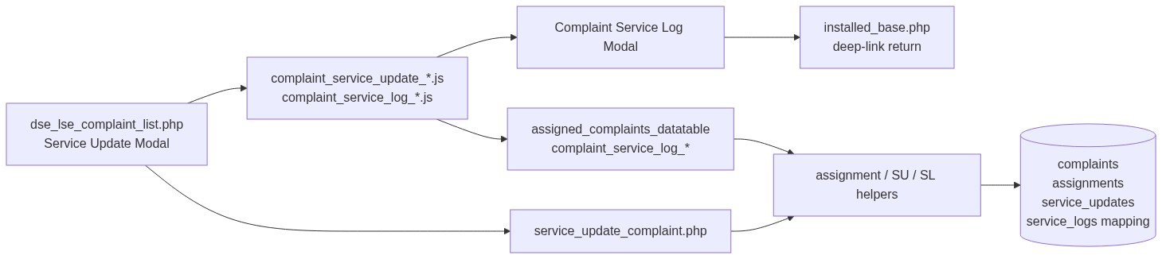
Figure 1 â€” High-level architecture
â”€â”€â”€â”€â”€â”€â”€â”€â”€â”€â”€â”€â”€â”€â”€â”€â”€â”€â”€â”€â”€â”€â”€â”€â”€â”€â”€â”€â”€â”€â”€â”€

2. Functional Requirements
ID | Requirement | Priority
FR-01 | Users with view can open Assigned List and details from=list | Must
FR-02 | List shows only In Progress / Re-Open with is_service_updated = 0 | Must
FR-03 | List visibility by role (admin / sales coordinator / assignee self) | Must
FR-04 | Users with service-update can open Service Update when eligible | Must
FR-05 | Service Update requires visit date, action taken, ≥1 service report | Must
FR-06 | Matching Installed Base (by FAB) required before SL / before SU | Must
FR-07 | Current-cycle Service Log required and must not be draft before SU | Must
FR-08 | Save Update inserts complaint_service_updates, sets assignment flag, status → Pending With HO | Must
FR-09 | Deep-link ?complaint_id=&open_service_update=1 reopens SU modal | Should
FR-10 | Add/edit/draft Service Log from complaint modal when SL add/edit permitted | Must
FR-11 | Multi-file reports: PDF/JPG/PNG/DOC/DOCX, ≤ 2 MB each | Must
FR-12 | After SU, row leaves Assigned List until Closure No → Re-Open cycle | Must

â”€â”€â”€â”€â”€â”€â”€â”€â”€â”€â”€â”€â”€â”€â”€â”€â”€â”€â”€â”€â”€â”€â”€â”€â”€â”€â”€â”€â”€â”€â”€â”€

3. User Roles & Permissions

3.1 RBAC module slug
assigned-complaint-list
Included in modules that enforce role_permissions (System Admin uses role grants, not full bypass).

3.2 Permission matrix
Permission slug | Capability
view | List, datatable, details from=list
service-update | Service Update page/modal, SL summary/prefill/draft APIs

Cross-module for SL modal: service-log-capture add and/or edit (modal shown only if service-update and SL add/edit).

3.3 Page / API mapping
Resource | Module | Permission
dse_lse_complaint_list.php | assigned-complaint-list | view
service_update_complaint.php | assigned-complaint-list | service-update
complaint_details.php (from=list) | assigned-complaint-list | view
api/assigned_complaints_datatable.php | assigned-complaint-list | view
api/complaint_service_log_summary.php | assigned-complaint-list | service-update
api/complaint_service_log_prefill.php | assigned-complaint-list | service-update
api/complaint_service_log_draft_save.php | assigned-complaint-list | service-update

Helpers: complaint_assigned_action_permissions(), complaint_assigned_require_page_access(), complaint_assigned_require_permission().

3.4 After-market / list scope (assigned)
Base filter (complaint_assigned_list_scope):
c.deleted_at IS NULL
AND ca.is_service_updated = 0
AND c.status IN (2 In Progress, 4 Re-Open)
Latest assignment via LATERAL join to complaint_assignments.
Role class | Extra filter
System Administrator | All matching rows
Sales Coordinator | Assignees in coordinator scope
Other users | ca.assigned_to = current_user_id OR assign display name = current assignee name
Unresolved identity | No rows (1 = 0)

Optional: complaint_id deep-link narrows to one complaint.
â”€â”€â”€â”€â”€â”€â”€â”€â”€â”€â”€â”€â”€â”€â”€â”€â”€â”€â”€â”€â”€â”€â”€â”€â”€â”€â”€â”€â”€â”€â”€â”€

4. Business Rules
ID | Rule
BR-01 | List only non-deleted, latest assignment not yet service-updated, status In Progress or Re-Open.
BR-02 | Service Update button only when service-update + eligible status + !is_service_updated.
BR-03 | Matching Installed Base required for complaint FAB before SL/SU.
BR-04 | Current-cycle Service Log required; must be final (not draft) before SU.
BR-05 | One SL per cycle (In Progress once; each Re-Open cycle numbered via complaint_service_logs).
BR-06 | SU always INSERTs a new complaint_service_updates row (not update-in-place).
BR-07 | On SU: set latest assignment is_service_updated = 1; complaint status = 3 (Pending With HO).
BR-08 | Part Replaced optional; Service Report required (multi-file).
BR-09 | Visit date: client not-future; server required Y-m-d (no future check on server).
BR-10 | After SU, complaint leaves Assigned List; Entry Closure needs Pending With HO + ≥1 SU.
BR-11 | Closure No (Entry) → new assignment (is_service_updated default 0) + Re-Open → returns to list.
BR-12 | No create/assign/closure/delete on this module.

Status constants: Open=1, In Progress=2, Pending With HO=3, Re-Open=4, Resolved=5.
â”€â”€â”€â”€â”€â”€â”€â”€â”€â”€â”€â”€â”€â”€â”€â”€â”€â”€â”€â”€â”€â”€â”€â”€â”€â”€â”€â”€â”€â”€â”€â”€

5. Database Design
Note: Current production uses PostgreSQL. Types below are MySQL-equivalent. List join uses INNER JOIN LATERAL (PG); MySQL 8+ can use equivalent lateral/derived join patterns.

5.1 ER diagram
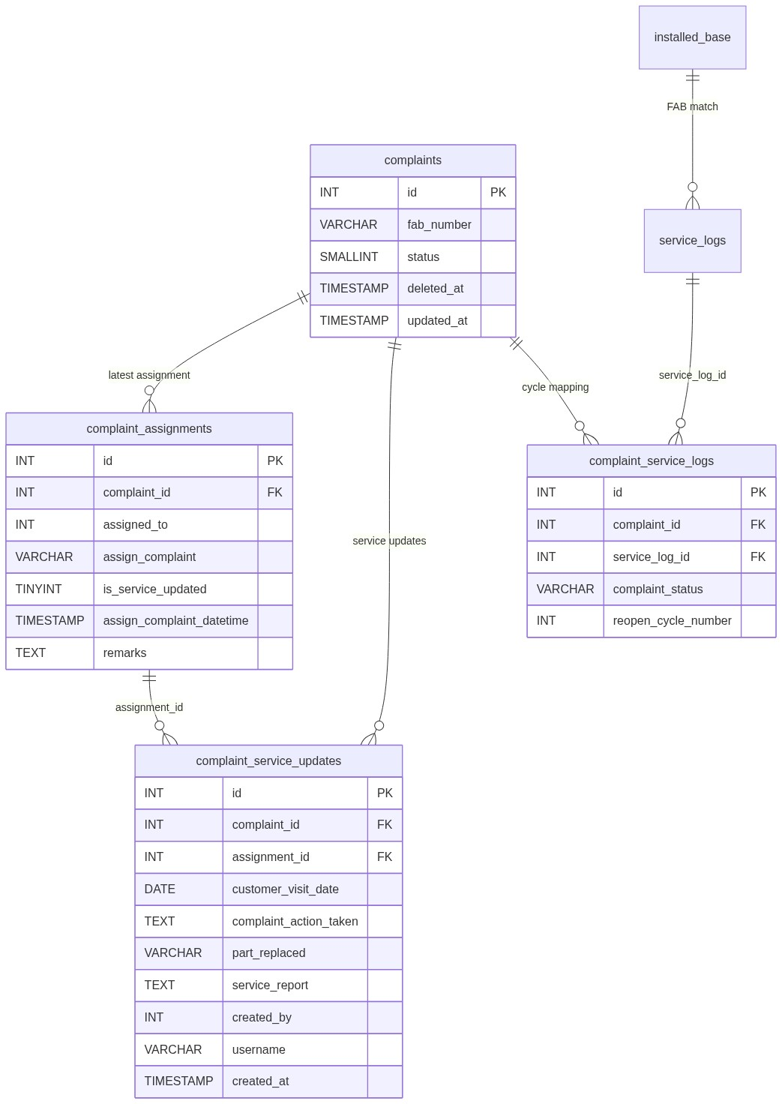
Figure 2 â€” Entity relationship diagram

5.2 Table: complaint_service_updates
Column | MySQL type | Null | Description
id | INT UNSIGNED AUTO_INCREMENT | NO | PK
complaint_id | INT UNSIGNED | NO | Complaint
assignment_id | INT UNSIGNED | NO | Latest assignment at SU time
customer_visit_date | DATE | NO | Visit date
complaint_action_taken | TEXT | NO | Action text
part_replaced | VARCHAR(255) | YES | Optional
service_report | TEXT | NO | JSON array of stored filenames
created_by | INT UNSIGNED | NO | Actor user id
username | VARCHAR(100) | YES | Actor username
created_at | TIMESTAMP | YES | Default now

5.3 Related tables
Table | Role
complaints | Status / FAB / soft-delete
complaint_assignments | Assignee + is_service_updated gate
complaint_activity_logs | Activity type Service Update
complaint_service_logs | Maps complaint cycle ↔ service_logs
service_logs | Current-cycle visit log (must be non-draft)
installed_base | Matched by FAB for SL bridge
Files under uploads/service_reports/ | Stored report binaries

5.4 Reference / lookup sources
Source | Usage
api/assigned_complaints_datatable.php | List data
api/complaint_service_log_summary.php | Cycle / IB / SL summary for modal
api/complaint_service_log_prefill.php | Prefill Add SL
api/machine_model_search.php | SL modal part rows
SCM warranty / part replaced | SL modal static Select2

â”€â”€â”€â”€â”€â”€â”€â”€â”€â”€â”€â”€â”€â”€â”€â”€â”€â”€â”€â”€â”€â”€â”€â”€â”€â”€â”€â”€â”€â”€â”€â”€

6. API / Backend Design

6.1 Page endpoints (HTML / form POST)
Endpoint | Method | Auth | Description
dse_lse_complaint_list.php | GET | view | Assigned list + SU modal
service_update_complaint.php | POST | service-update | Save Service Update
complaint_details.php?id=&from=list | GET | view + assigned ACL | Details
installed_base.php?...&open_service_update=1 | GET | IB module | Return after IB create

Non-POST to service_update_complaint.php → access_denied.php.

Service Update POST fields
Field | Notes
complaint_id | Required
customer_visit_date | Required Y-m-d
complaint_action_taken | Required
part_replaced | Optional
service_report[] | Multi-file required

6.2 JSON APIs

POST api/assigned_complaints_datatable.php
Scoped assigned list.

GET api/complaint_service_log_summary.php?complaint_id=
Cycle label, IB presence, current-cycle SL summary, permissions, optional installed_base_add_url.

GET api/complaint_service_log_prefill.php?complaint_id=
Prefill for Add SL (IB, fab, machine, serial peek, description, cycle).

POST api/complaint_service_log_draft_save.php
Draft SL with from_complaint_modal=1 + mapping row.

6.3 Supporting lookup APIs
API | Purpose
api/service_log_get.php | Edit existing cycle SL (extra complaint ACL)
api/service_log_create.php / update.php | Final SL from complaint modal
api/machine_model_search.php | Part replacement Select2

6.4 Core PHP module responsibilities
Module / file | Responsibility
includes/complaint_assignment_helpers.php | Assigned list scope / access
includes/complaint_datatable_helpers.php | Assigned actions HTML / perms
includes/complaint_service_update_save_helpers.php | SL prerequisite validation
includes/service_report_helpers.php | Upload validate/store
includes/complaint_service_log_helpers.php | Cycles, summary, prefill, access
includes/complaint_service_log_draft_helpers.php | Draft save
includes/complaint_activity_helpers.php | Activity log
service_update_complaint.php | Transactional SU save

â”€â”€â”€â”€â”€â”€â”€â”€â”€â”€â”€â”€â”€â”€â”€â”€â”€â”€â”€â”€â”€â”€â”€â”€â”€â”€â”€â”€â”€â”€â”€â”€

7. Validation Rules

7.1 Server-side (Service Update)
Rule | Error message
Missing date/action | Customer visit date and complaint action taken are required.
Bad date | Invalid customer visit date.
Wrong status / cycle | Service update is only allowed for complaints in progress or re-open.
No IB | A matching installed base is required before a service log can be added.
No SL | Please add a Service Log to proceed further.
Draft SL | Service Log is in Draft. It will not be sent for HO Approval. Please submit the Service Log before updating the complaint.
No file | At least one service report file is required
Bad type | Invalid file type for "{name}". Allowed: PDF, JPG, PNG, DOC, DOCX.
Size | File "{name}" must be 2 MB or smaller.
Not found | Complaint not found.
Outside scope | Access denied. You do not have permission to update this complaint.
No assignment | No assignment found for this complaint.
Upload dir / store | Unable to create upload directory. / Unable to store service report upload.
Persist | Failed to save service update.

7.2 Client-side (active: js/complaint_service_update_save.js)
Rule | Message
Visit date empty | Customer visit date is required
Visit date future | Customer visit date cannot be in the future
Action empty | Complaint action taken is required
No files / type / size | Same as server (without trailing period on type in some paths)
SL loading | Service log details are still loading. Please wait.
No IB / no SL / draft | Same wording as server helper messages

Note: js/service_update_validation.js exists but is not loaded (orphan).
â”€â”€â”€â”€â”€â”€â”€â”€â”€â”€â”€â”€â”€â”€â”€â”€â”€â”€â”€â”€â”€â”€â”€â”€â”€â”€â”€â”€â”€â”€â”€â”€

8. UI Screen Specifications

8.1 Listing — dse_lse_complaint_list.php
Element | Spec
Title | Assigned Complaint List
Grid | ID, Fab, Customer, Category, Assigned To, Assigned Date, Remarks, optional Added By, Status, Action
Empty | No assigned complaints found. / No matching assigned complaints found.
Order | Assigned Date desc (default)
Status cards | CSS present; cards not included on this page

8.2 Form panel
N/A for list. Service Update is a modal, not a slide-in create form.

8.3 Details — complaint_details.php?from=list
Read-only complaint details under assigned ACL. Back to Assigned List.

8.4 Modals (from listing)
Modal | Purpose
#serviceUpdateModal | Visit date, optional part replaced, action taken, SL section, service reports, Save Update
#installedBaseServiceLogModal (data-context="complaint") | Add/edit/draft Service Log for current cycle

Service Update subtitle: Record visit details and submit for Head Office approval.
Notice: HO Approval Required.
â”€â”€â”€â”€â”€â”€â”€â”€â”€â”€â”€â”€â”€â”€â”€â”€â”€â”€â”€â”€â”€â”€â”€â”€â”€â”€â”€â”€â”€â”€â”€â”€

9. Database Flow

9.1 Create (Service Update)
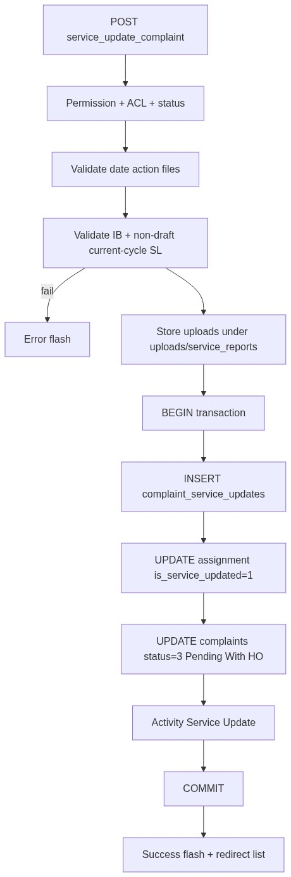
Figure 3 â€” Create database flow

9.2 Soft-delete
Not performed by this module. Soft-delete remains Complaint Entry (delete_complaint.php).

9.3 List query pattern
SELECT c.*, ca.*
FROM complaints c
INNER JOIN LATERAL (
SELECT * FROM complaint_assignments
WHERE complaint_id = c.id
ORDER BY id DESC
LIMIT 1
) ca ON TRUE
WHERE c.deleted_at IS NULL
AND ca.is_service_updated = 0
AND c.status IN (2, 4)
AND /* role assignee scope */
ORDER BY ca.assign_complaint_datetime DESC
LIMIT :limit OFFSET :offset;
â”€â”€â”€â”€â”€â”€â”€â”€â”€â”€â”€â”€â”€â”€â”€â”€â”€â”€â”€â”€â”€â”€â”€â”€â”€â”€â”€â”€â”€â”€â”€â”€

10. Sequence Diagram

10.1 Service Update submit
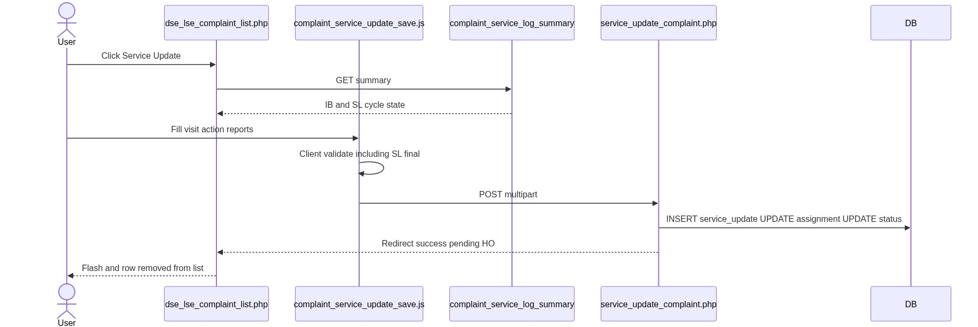
Figure 4 â€” Sequence: Create / update on Spare Parts page

10.2 Add Service Log from Service Update (current cycle)
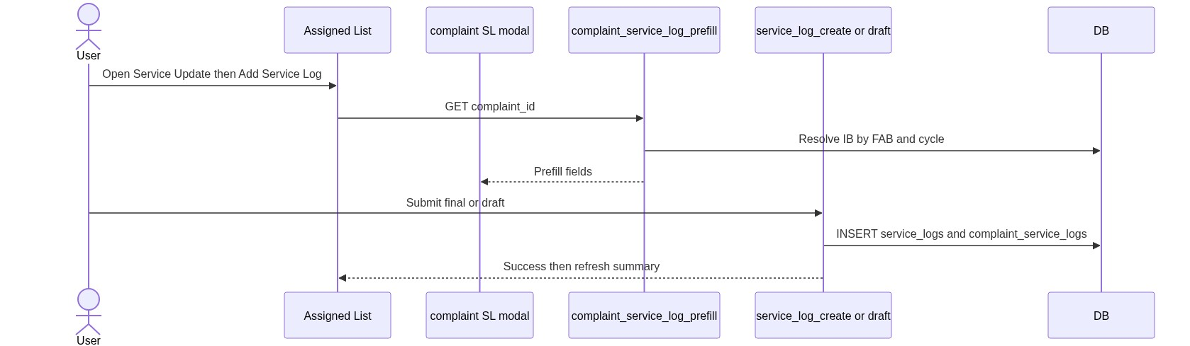
Figure 5 â€” Sequence: Add Spare Parts from IB / SL row
â”€â”€â”€â”€â”€â”€â”€â”€â”€â”€â”€â”€â”€â”€â”€â”€â”€â”€â”€â”€â”€â”€â”€â”€â”€â”€â”€â”€â”€â”€â”€â”€

11. Activity Diagram
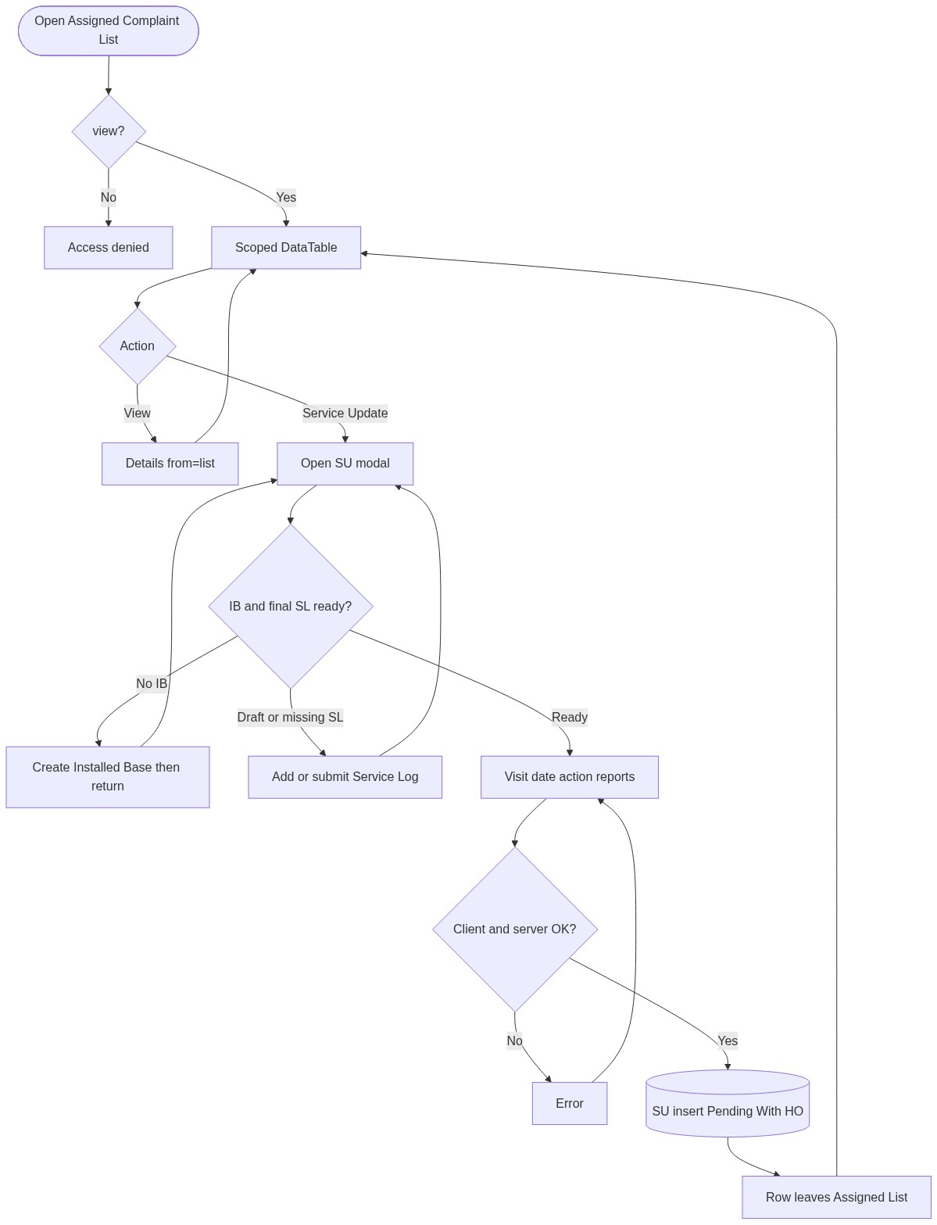
Figure 6 â€” Activity diagram
â”€â”€â”€â”€â”€â”€â”€â”€â”€â”€â”€â”€â”€â”€â”€â”€â”€â”€â”€â”€â”€â”€â”€â”€â”€â”€â”€â”€â”€â”€â”€â”€

12. Class / Module Diagram
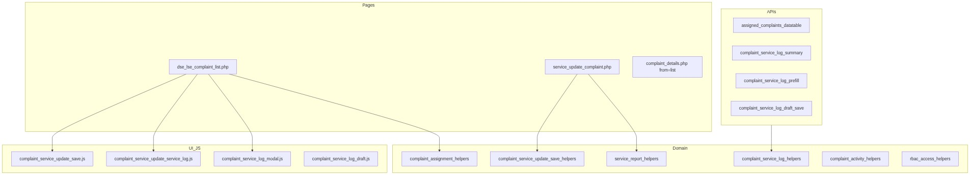
Figure 7 â€” Class / module diagram

12.1 Key functions
Function / area | Role
complaint_assigned_list_scope() | Who sees which rows
complaint_user_can_access_assigned_complaint() | Per-complaint ACL
complaint_assigned_action_permissions() | View / Service Update flags
complaint_service_update_validate_service_log() | IB + final SL gate
Service report helpers | Validate/store multi uploads
Complaint SL summary / prefill / draft | Cycle bridge to Service Log
Activity Service Update | Audit description

â”€â”€â”€â”€â”€â”€â”€â”€â”€â”€â”€â”€â”€â”€â”€â”€â”€â”€â”€â”€â”€â”€â”€â”€â”€â”€â”€â”€â”€â”€â”€â”€

13. Folder Structure
ComplaintManagement/
├── dse_lse_complaint_list.php
├── service_update_complaint.php
├── complaint_details.php
├── api/
│ ├── assigned_complaints_datatable.php
│ ├── complaint_service_log_summary.php
│ ├── complaint_service_log_prefill.php
│ └── complaint_service_log_draft_save.php
├── includes/
│ ├── complaint_assignment_helpers.php
│ ├── complaint_datatable_helpers.php
│ ├── complaint_service_update_save_helpers.php
│ ├── complaint_service_update_save_actions.php
│ ├── complaint_service_log_helpers.php
│ ├── complaint_service_log_modal.php
│ ├── complaint_service_log_draft_helpers.php
│ ├── complaint_service_log_draft_actions.php
│ ├── service_report_helpers.php
│ └── rbac_*.php
├── js/
│ ├── complaint_service_update_service_log.js
│ ├── complaint_service_update_save.js
│ ├── complaint_service_log_modal.js
│ └── complaint_service_log_draft.js
├── css/
│ └── dse_lse_complaint.css
├── uploads/service_reports/
└── docs/
└── LLD_Assigned_Complaint_List_Module.md
â”€â”€â”€â”€â”€â”€â”€â”€â”€â”€â”€â”€â”€â”€â”€â”€â”€â”€â”€â”€â”€â”€â”€â”€â”€â”€â”€â”€â”€â”€â”€â”€

14. Error Handling
Layer | Pattern
SU POST | Session error_message + redirect list
SU success | Session success_message
JSON APIs | 401 / 403 / 404 / 422 + {"error":"..."}
Client | Inline field / alert messages before POST

14.1 Common messages
Message | When
Access denied. You do not have permission to update this complaint. | Outside assigned scope
Access denied. You do not have permission to view this complaint. | Details deny
Service update is only allowed for complaints in progress or re-open. | Wrong status
A matching installed base is required before a service log can be added. | No IB
Please add a Service Log to proceed further. | No SL
Service Log is in Draft. It will not be sent for HO Approval... | Draft SL
Failed to save service update. | Transaction failure
Unable to resolve logged-in user. | Missing actor

â”€â”€â”€â”€â”€â”€â”€â”€â”€â”€â”€â”€â”€â”€â”€â”€â”€â”€â”€â”€â”€â”€â”€â”€â”€â”€â”€â”€â”€â”€â”€â”€

15. Security Considerations
Area | Control
SQL Injection | PDO prepared statements
XSS | Escaped listing/details output
CSRF | Session POST; recommend CSRF tokens
Authentication | Portal session
Authorization | RBAC + assigned list scope + status gates
Uploads | Extension allow-list, 2 MB cap, stored outside public guessable names where helpers apply
IDOR | Assigned ACL on SU / details / SL APIs
Soft-delete | Complaints with deleted_at excluded

â”€â”€â”€â”€â”€â”€â”€â”€â”€â”€â”€â”€â”€â”€â”€â”€â”€â”€â”€â”€â”€â”€â”€â”€â”€â”€â”€â”€â”€â”€â”€â”€

16. Audit Logs

16.1 Built-in field-level audit
Entity | Fields
complaint_service_updates | created_by, username, created_at
complaint_activity_logs | activity_type = Service Update, description, user_id, username
complaints | updated_at on status change
complaint_assignments | is_service_updated flag

No separate dedicated audit table beyond activity logs.
â”€â”€â”€â”€â”€â”€â”€â”€â”€â”€â”€â”€â”€â”€â”€â”€â”€â”€â”€â”€â”€â”€â”€â”€â”€â”€â”€â”€â”€â”€â”€â”€

17. Test Cases

17.1 Functional
ID | Scenario | Expected
TC-01 | Assignee opens list | Sees own In Progress / Re-Open not yet SU
TC-02 | Admin opens list | Sees all matching assigned rows
TC-03 | After SU | Row gone; status Pending With HO
TC-04 | SU without visit/action/files | Validation errors
TC-05 | Future visit date (client) | Blocked
TC-06 | SU without IB | IB required message
TC-07 | SU with draft SL only | Draft HO message
TC-08 | SU with final SL + files | Success pending HO flash
TC-09 | Invalid/oversized report | File validation errors
TC-10 | Deep-link open_service_update | Modal opens for complaint
TC-11 | Add IB then return | Success + SU modal reopen
TC-12 | Add SL from modal | Summary shows final SL
TC-13 | Duplicate cycle SL | Prefill blocks second create
TC-14 | Closure No then reopen | Complaint returns to Assigned List
TC-15 | User without service-update | No SU button
TC-16 | Details from=list outside scope | Access denied

â”€â”€â”€â”€â”€â”€â”€â”€â”€â”€â”€â”€â”€â”€â”€â”€â”€â”€â”€â”€â”€â”€â”€â”€â”€â”€â”€â”€â”€â”€â”€â”€

18. Assumptions & Dependencies

18.1 Assumptions
1. Users authenticate via portal session.
2. RBAC for assigned-complaint-list (view, service-update) is seeded.
3. Complaints reach this list only after Entry assignment (In Progress) or Closure No (Re-Open).
4. Installed Base and Service Log modules are available for the FAB/cycle bridge.
5. uploads/service_reports/ is writable by the app.
6. Document target stack is Core PHP + MySQL; repo currently runs PostgreSQL.

18.2 Dependencies
Dependency | Purpose
Complaint Entry | Create / assign / closure lifecycle
Installed Base Capture | FAB machine master for SL
Service Log Capture | Current-cycle visit log
Session + RBAC | AuthZ
jQuery + DataTables + Bootstrap + Select2 (SL modal) | UI
File upload helpers | Service reports

â”€â”€â”€â”€â”€â”€â”€â”€â”€â”€â”€â”€â”€â”€â”€â”€â”€â”€â”€â”€â”€â”€â”€â”€â”€â”€â”€â”€â”€â”€â”€â”€

Appendix A — Success flash query flags
Event | Message
Service Update saved | Service update is currently pending with HO (Head Office) for approval.
IB saved then return | Installed base record saved successfully. (then reopen SU)
SL draft from complaint | Service log saved as draft successfully. / Service log draft updated successfully.

(No dedicated ?su_saved=1 query flag; session flash + redirect to list.)
â”€â”€â”€â”€â”€â”€â”€â”€â”€â”€â”€â”€â”€â”€â”€â”€â”€â”€â”€â”€â”€â”€â”€â”€â”€â”€â”€â”€â”€â”€â”€â”€

Appendix B — Select2 control map
Control | Where | API / mode
— | Assigned list / SU visit fields | No Select2
Warranty / Chargeable | Complaint SL modal | Static SCM
Part Replaced | Complaint SL modal | Static SCM
Machine Model / Part rows | Complaint SL modal | api/machine_model_search.php

â”€â”€â”€â”€â”€â”€â”€â”€â”€â”€â”€â”€â”€â”€â”€â”€â”€â”€â”€â”€â”€â”€â”€â”€â”€â”€â”€â”€â”€â”€â”€â”€

Appendix C — Distinction vs Complaint Entry
 | Complaint Entry | Assigned Complaint List
Module | complaint-entry | assigned-complaint-list
Page | new_complaint.php | dse_lse_complaint_list.php
Datatable | api/complaints_datatable.php | api/assigned_complaints_datatable.php
Details | from=entry | from=list
Key writes | Create / assign / close / delete | Service Update (+ SL/IB bridge)

â”€â”€â”€â”€â”€â”€â”€â”€â”€â”€â”€â”€â”€â”€â”€â”€â”€â”€â”€â”€â”€â”€â”€â”€â”€â”€â”€â”€â”€â”€â”€â”€
End of LLD — Assigned Complaint List Module

